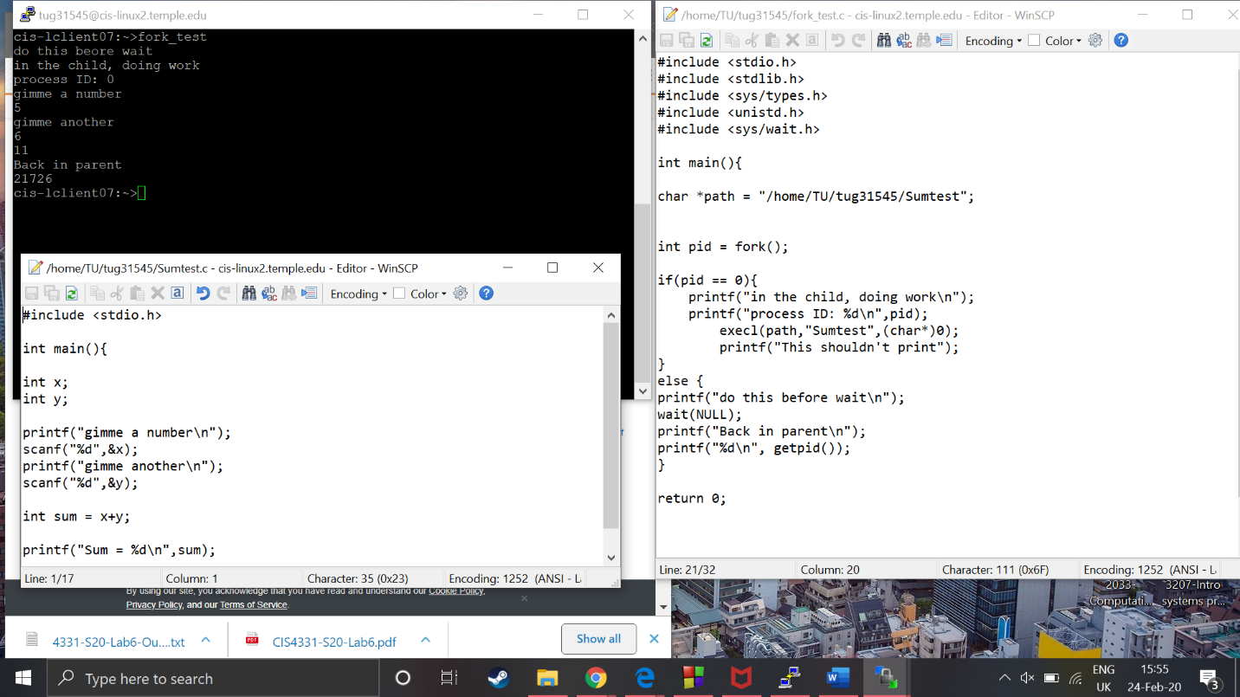Fork now works as expected, my screen shot shows my fork being created and its pid , it shows my parent doing work before the wait, my child calls the test function I created and it executes as it should.

I then get back to my parent and it prints its pid just to confirm